**7INNOVA T13**

InnoX Challenge Final Report

TEAM J.E.R.K

YONG KAI EN S10173513B

RYAN TAN WEI REN S10175941E

JOACHIM LEE S10171146F

TAN EK HERN S10161124E

**Product Description****3**

**Product Benefits****4**

**Product Response****4**

**Price of Product****4**

**Concerns by the Consumers****6**

**Appendix A - Market Research Questionnaire****7**

**Appendix B - Market Research Results****8**

InnAcc Official Website: http://s10173513.wixsite.com/mysite-1

# 

# 

# **Product Description**

The product that our group has decided to work on is a private indoor space named Indoor Accommodation or InnAcc in short that is to be built at East Coast Park. The basic concept behind InnAcc is that it provides park-goers a place to conduct their own activities designed and dedicated to their private and personal usage. Due to the nature of this project, many designs of InnAcc can be made to suit the different needs and requirements. This variation in design means that InnAcc can be built in different environments which allows it to be built at the other parks as well. The base design at East Coast Park is to provide users with a spacious accommodation design, various chair designs and differing layouts in each space. Users will have to book in advance by calling the hotline in order to use these spaces. The picture below shows an early concept of an outdoor version of InnAcc as a public space.

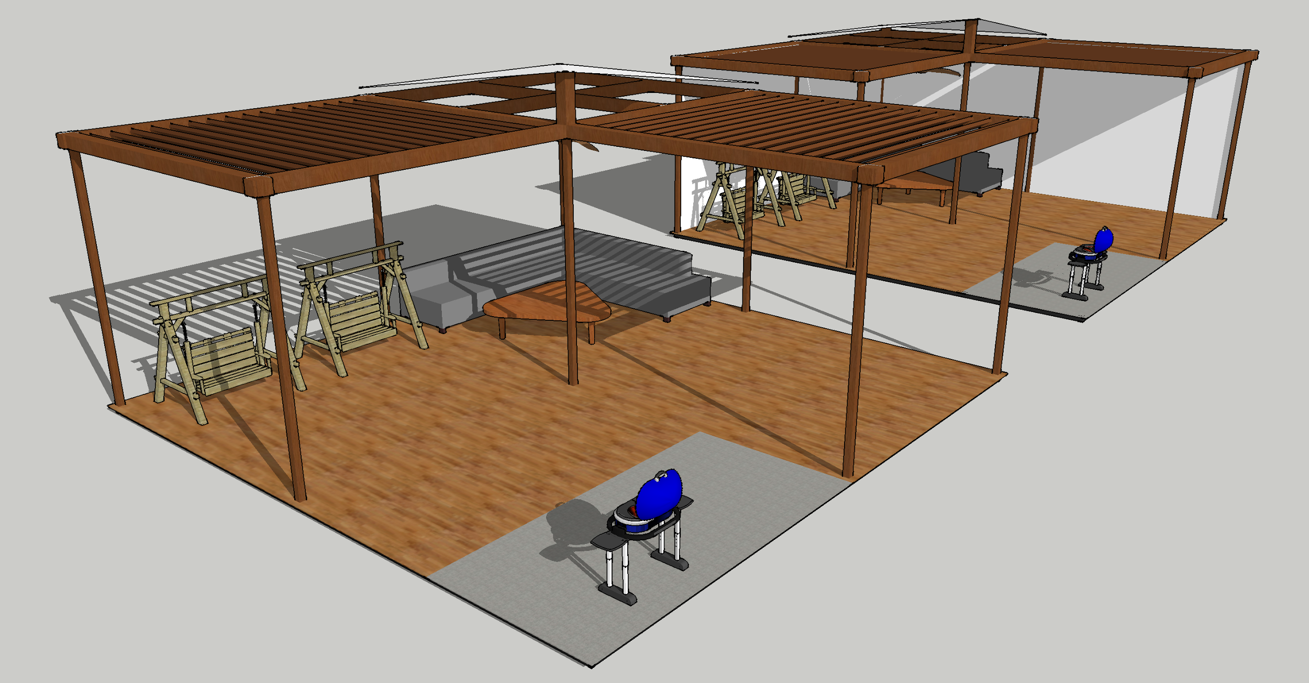

*(Outdoor InnAcc as a public space, Team’s final ideation product)*

After collating the feedbacks from the survey, the picture below shows an example of the improved version of InnAcc as a indoor private space for users.

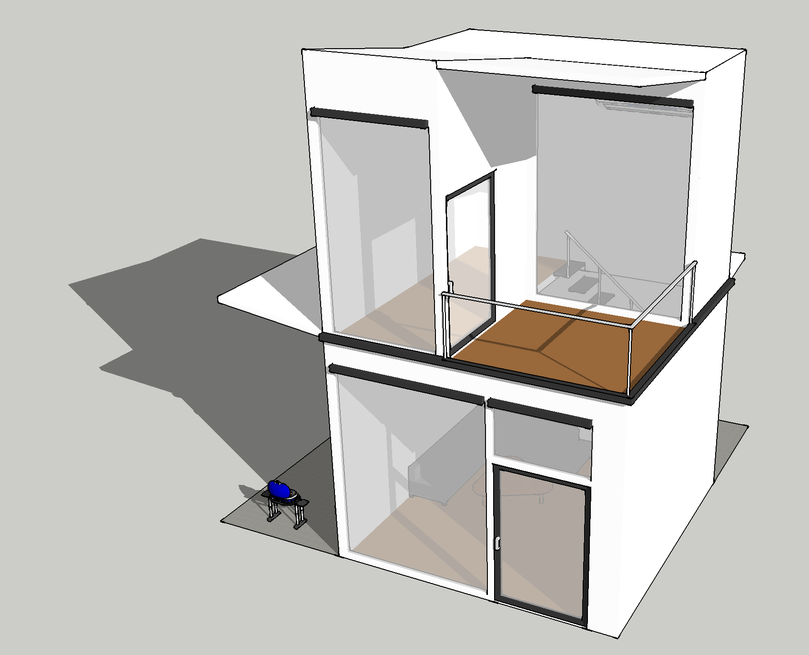

*(InnAcc as an indoor private space, Team’s final ideation product)*

# **Product Benefits**

InnAcc brings about numerous benefits from different perspective of the public. We have highlighted a few of the main benefits that users can gain from it. The benefits are as listed below.

* Firstly, it allows users to have a private space of their own in a public area. This gives users a sense of comfort that makes them feel as if they are in their own living room at home.
* Second, it serves as an alternative shelter during bad weather. InnAcc, as compared to a generally designed Gazebo, is able to protect users better from the rain, hence users will not be wet especially during heavy downpours.
* Thirdly, InnAcc serves as a multi-purpose venue. Users can do various activities in InnAcc without being restricted, such as doing work/studying, games among friends and/or family, chatting as well as indoor barbecue.
* In addition, InnAcc gives a modern vibe to East Coast Park. With Singapore developing fast as a first-world country, it has to keep up to its looks. InnAcc incorporates as many of the current technology as possible to fit this image.
* Fourth, it provides park-goers with a clean place to cool down at. Some users may feel that the Gazebo around East Coast Park are dirty and unsettling to their sight. Hence InnAcc provides the space which meets their expectation.
* Fifth, it is able to better contain rowdy groups. InnAcc can be designed either with soundproof walls or hollow ceilings with small holes in it to reduce the noise pollution directed towards other users or passer-bys. This way, not only will the group not be judged as a nuisance but also the peace and tranquility at the park will not be disturbed.
* Lastly, it provides users with a secured environment. When one rents InnAcc, they are given keys to the specific room/space they have booked. Therefore, users can lock the space up with their valuables in it to prevent thief and a place to put bulky items.

# **Product Response**

Based on the responses that we have received and consolidated, 44 out of 51 respondents feel and think that InnAcc will be beneficial towards them when they visit East Coast Park, forming a high percentage of 86.3%. To improve on our project, we have decided that we should emphasise more on the responses given by respondents under “Below 18 years old” and “18 years old to 25 years old”. This is because they form a majority of the respondents (44, 86.3%), and they tend to visit East Coast Park more often than other age groups (3 out of 5 visiting once every two weeks, 10 out of 11 visiting once every month). Therefore, focusing on their responses will be more useful to us.

# 

# **Price of Product**

We had no original rental rate for InnAcc, therefore we decided to let our respondents to vote on the rate they preferred the most in the survey. Through the results that we have collated, out of the 51 respondents, majority of the respondents (58.8%) felt that $10 per hour is the most reasonable rental rate for InnAcc. Also, 31.4% felt that $5 per hour is the most justified.

**Product Improvements**

In order for InnAcc to be better perceived by the public, we have came up with a number of improvements for the project. However, we narrowed it down to a few major improvements that needs to be addressed immediately. They are as listed below.

* **Addition of entertainment system**

Some respondents have suggested adding entertainment system such as televisions,

projectors, screen etc. We have decided to follow through with this suggestion as some

users may be study groups and may want to use the projector for that purposes. Other

users may be polytechnic students who may want to practise their presentation slides

but have no place to do so. As such, considering the needs of various groups of users,

we intend to add it in.

* **Convenient Booking Scheme**

We have decided to add various ways for users to book InnAcc other/rather than using

call booking. A website will be created and can be posted on the East Coast Park

website which allow users to book a space at InnAcc and pay for the rental through

credit/debit card or on-site cash payment. In addition, we will offer walk-in booking which

only allows cash payments. In order to do so, a worker needs to be hired to manage the

bookings from both online and on-site.

* **Offering Different InnAcc Packages**

In addition, we are thinking of including packages for users to choose from. The content

of each package varies depending on the purpose the package serves. Users can book the packages based on their personal needs and interests. We have planned five packages that we feel that it will be attractive to the users.

* **Clubhouse**  
  It is a room that is designated for group bonding. There are multimedia systems such as television and sound system, air-conditioning that are available so that users can rest in the accommodation after a hot day outside in East Coast Park. There are also barbeque pits available so users can use that to host a barbeque session in the case of wet weather.
* **Function Room**  
  It is a room that is designated for a large group of people. Users can use this room for company meeting or convention level of exhibition.
* **Gaming Room**

It is a room that is designates for users who love gaming. Gaming accessories such as computers, computer mouse, keyboard will be provided in the accommodation so that users can enjoy their favourite computer games after a hot day outside in East Coast Park.

* **Music Room**  
  It is a room that is designated for users who love music. Park-goers can rent this accommodation room as a private space, and also able to play with the music instruments that are available indoors. The walls will be soundproof, therefore they can play to their heart's content without worrying about being a disturbance to others.
* **Sports Room**

An Inhouse Accommodation for Sports Enthusiasts. This is the first gym available in East Coast Park, where it can accommodate up to 8 guests. Park-goers can rent this accommodation room as a private space, and are also able to workout indoors at the same time. Gym equipment such as Weightlift, Bench Press, Pullup Bars are provided.

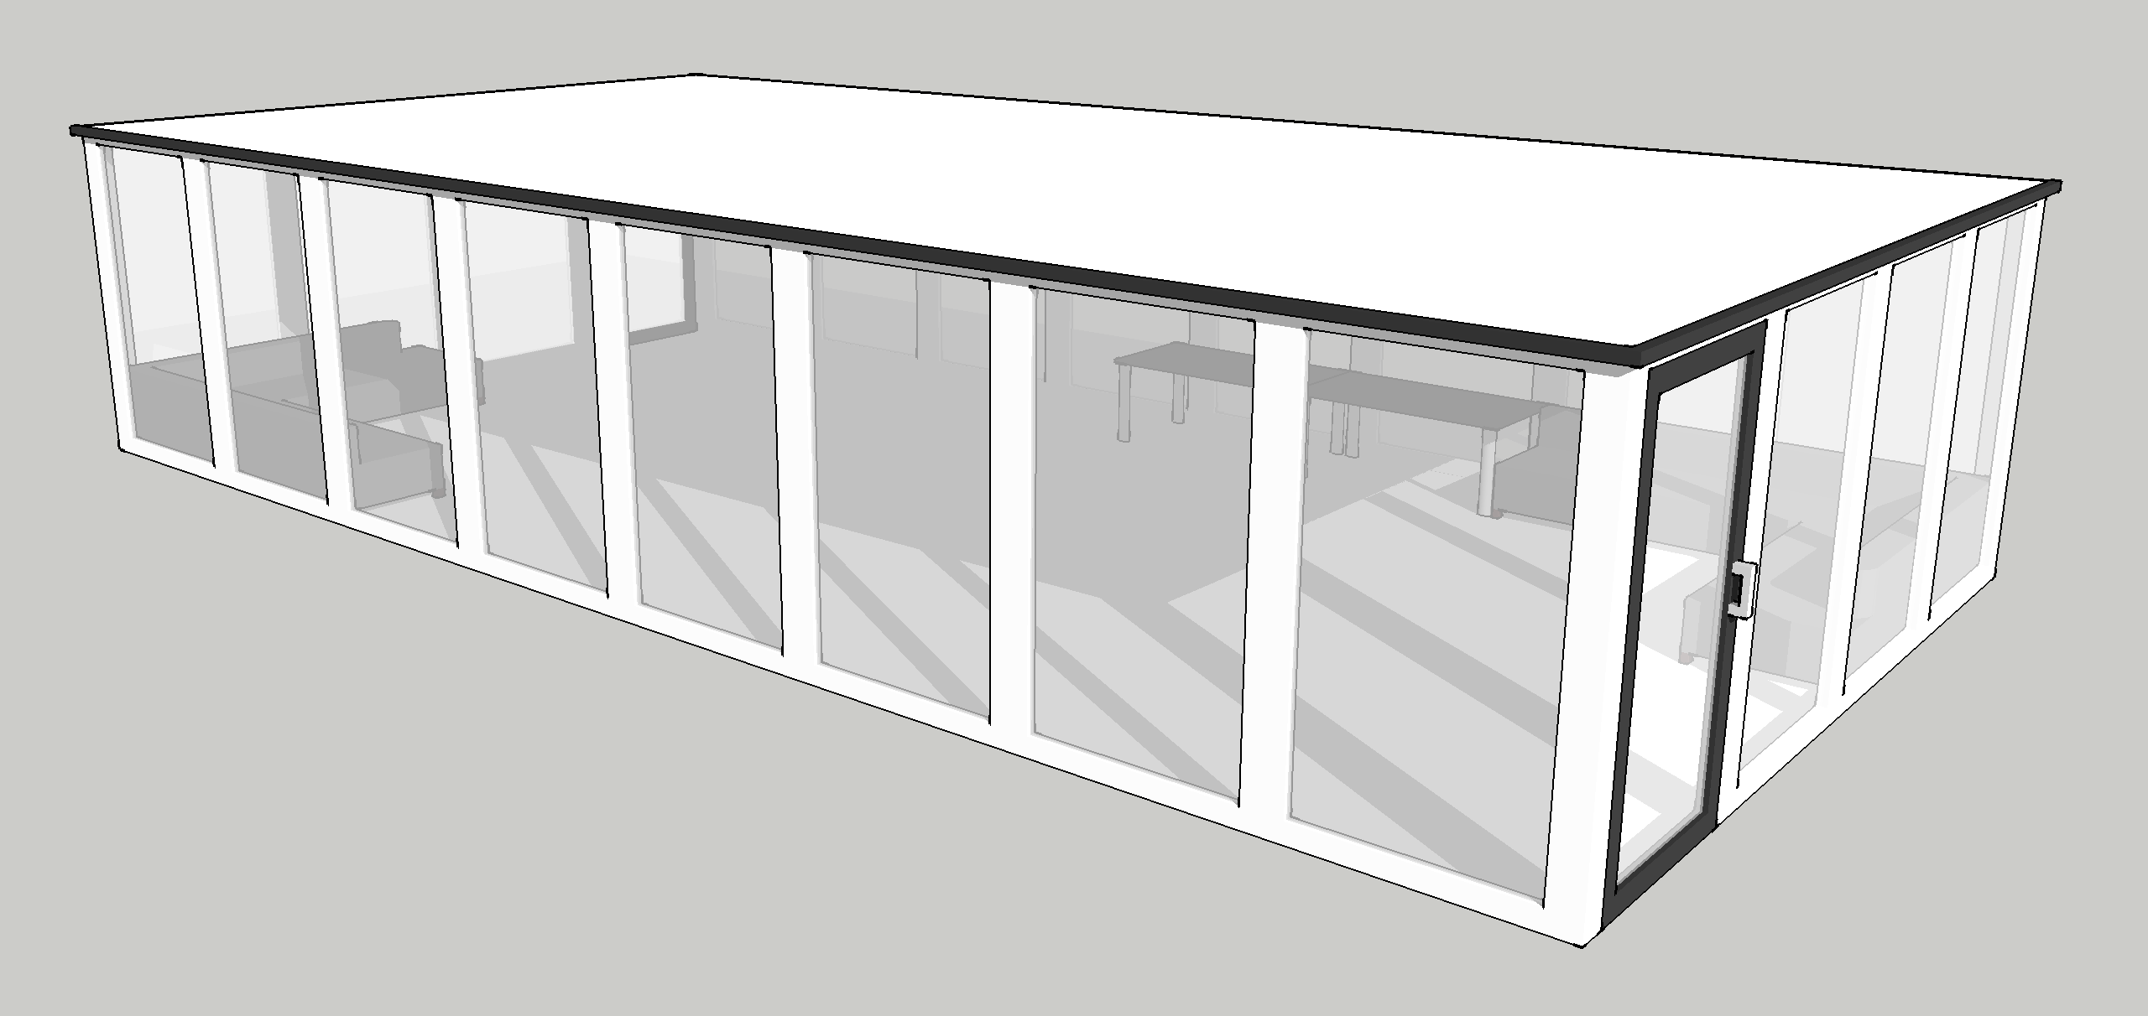

*(Picture above is a concept design of the Function Room)*

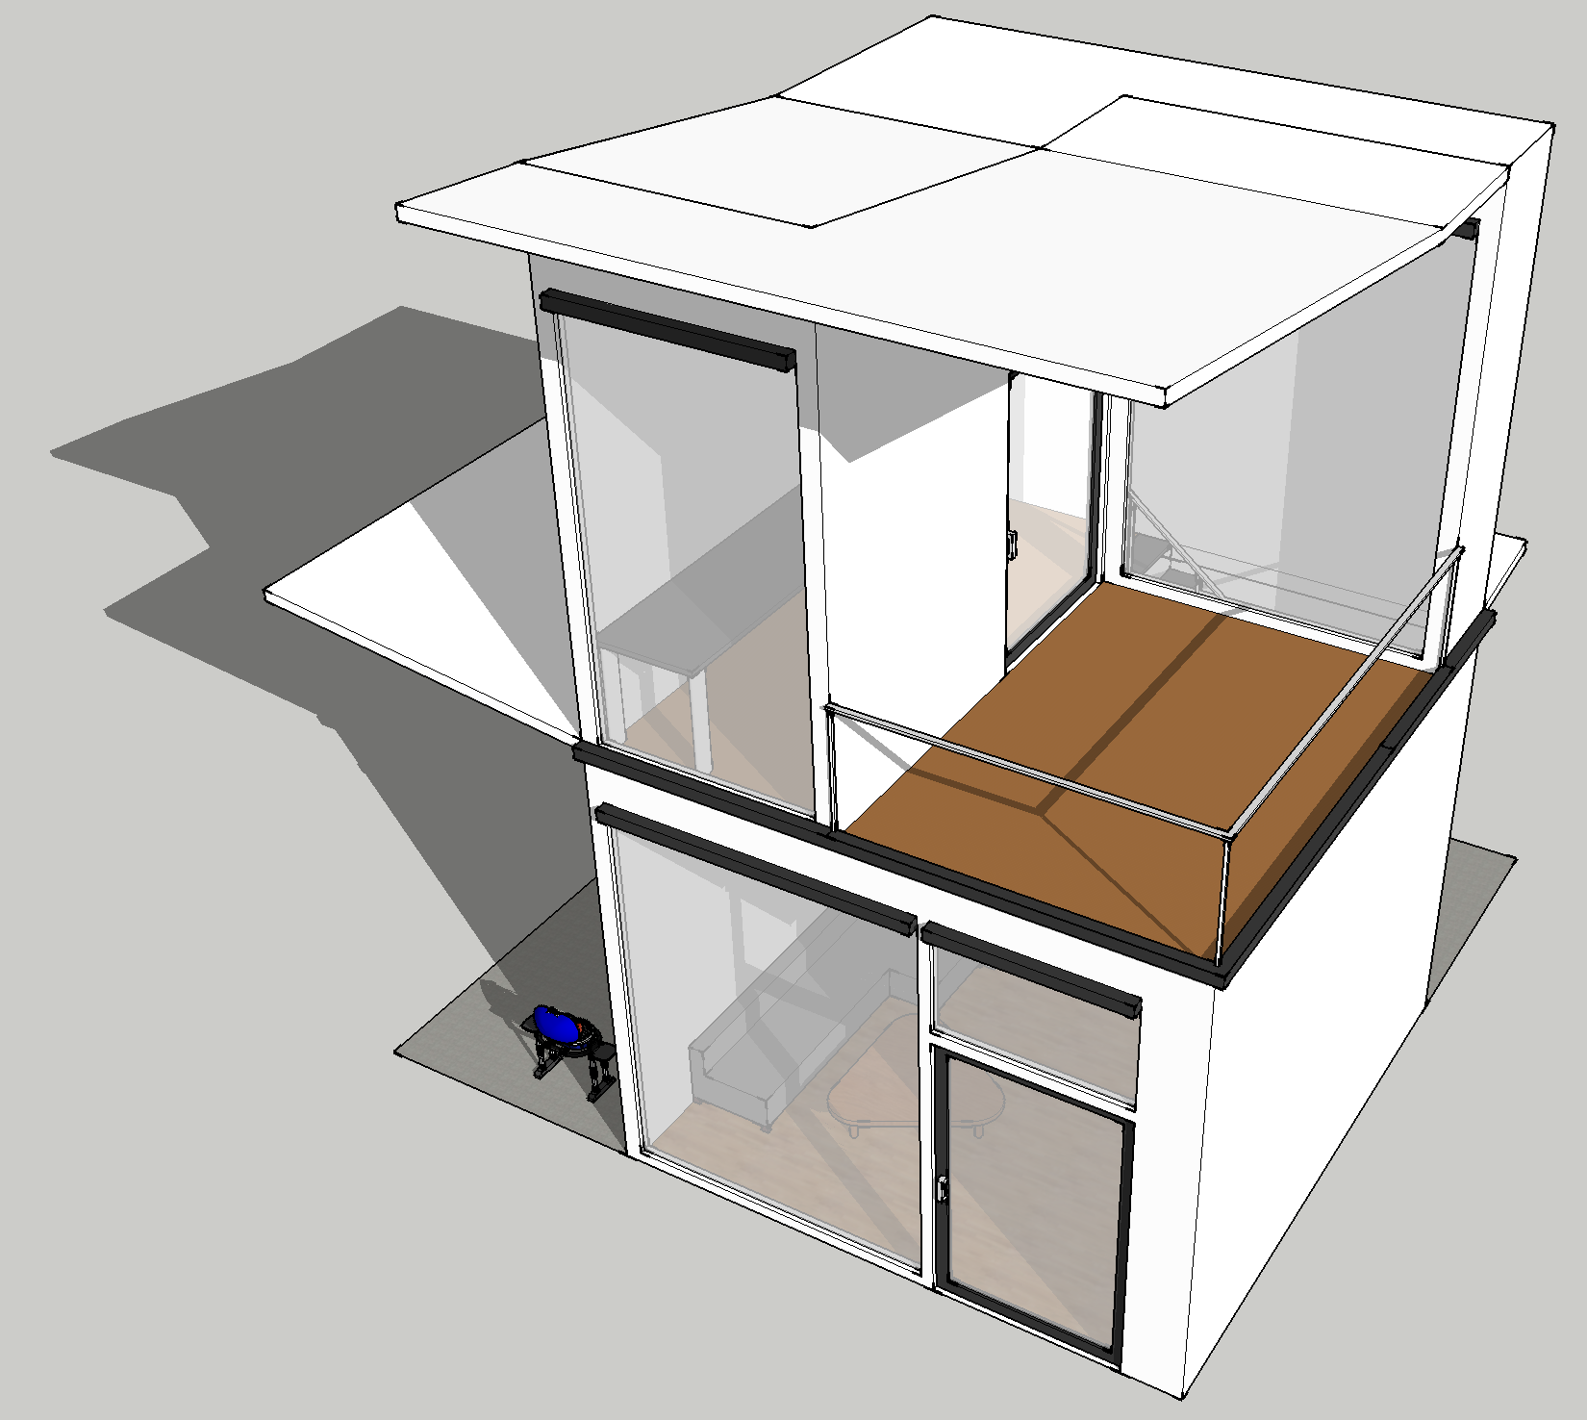

*(An improved version of the early indoor InAcc, becoming the Clubhouse)*

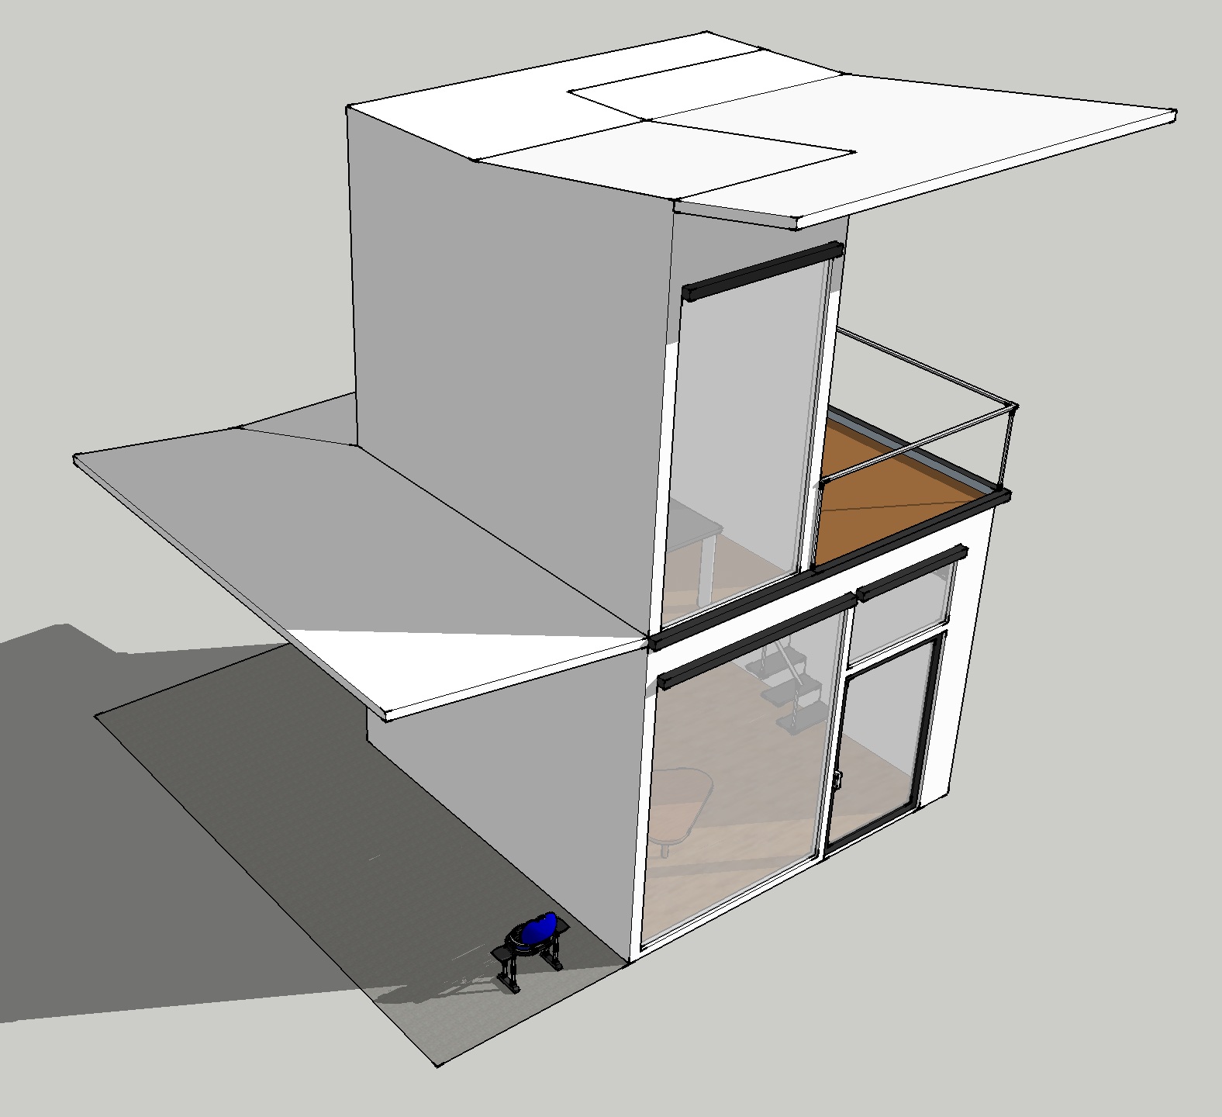

*(A side view of the Clubhouse)*

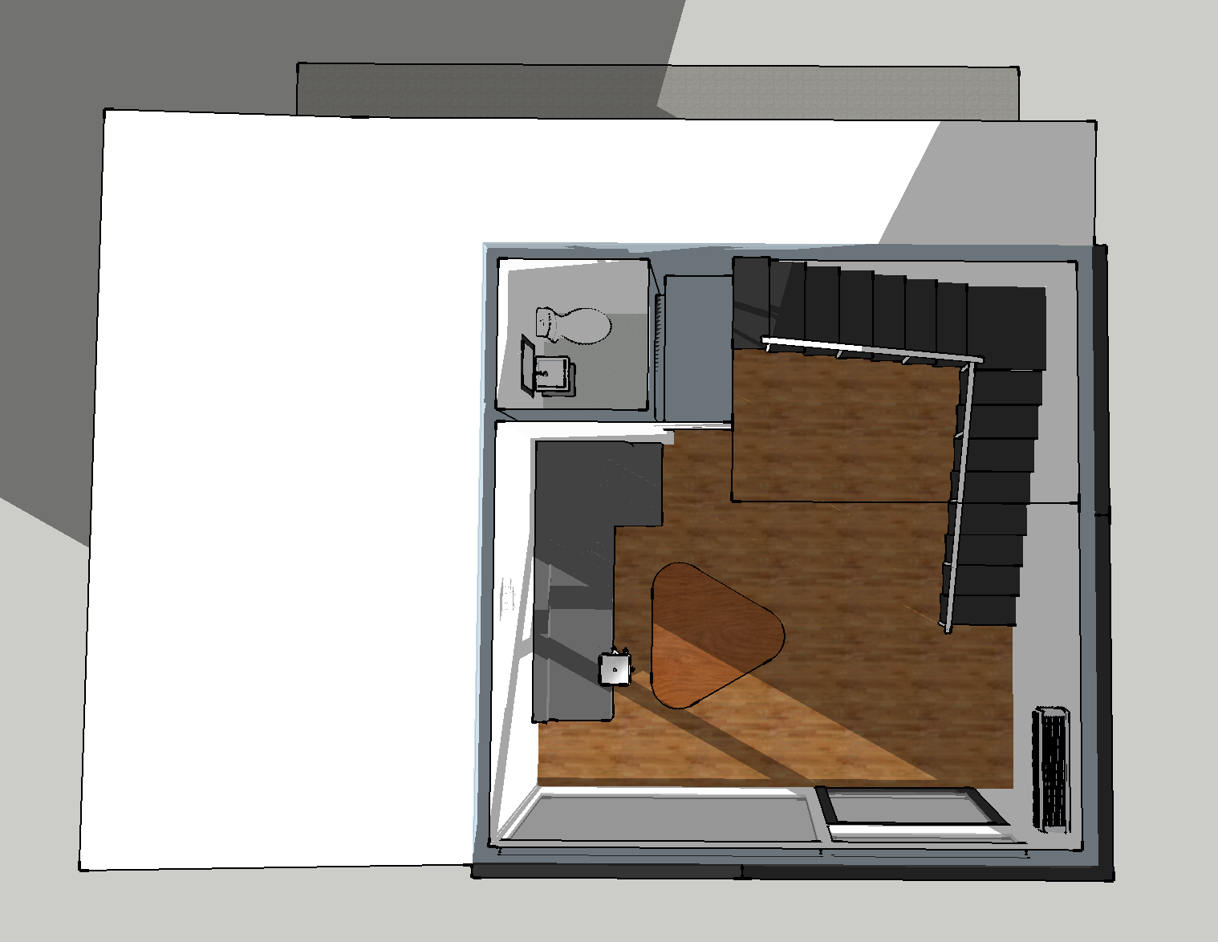

*(Level 1 Interior of the Clubhouse)*

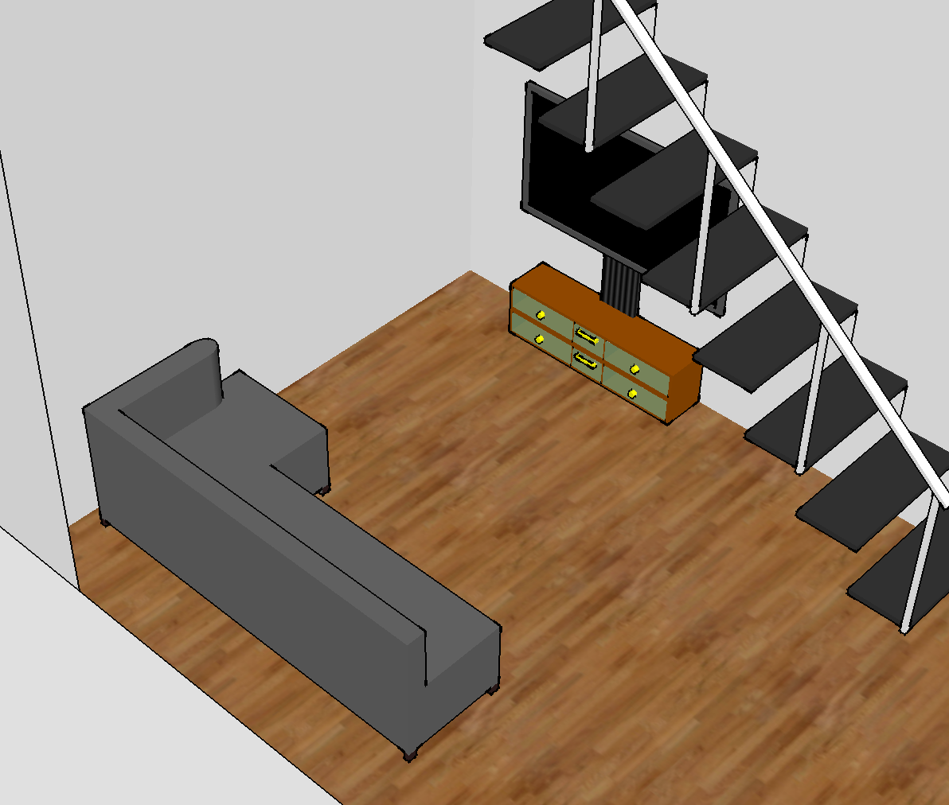

*(Level 1 Interior of the Clubhouse, showing the multimedia systems)*

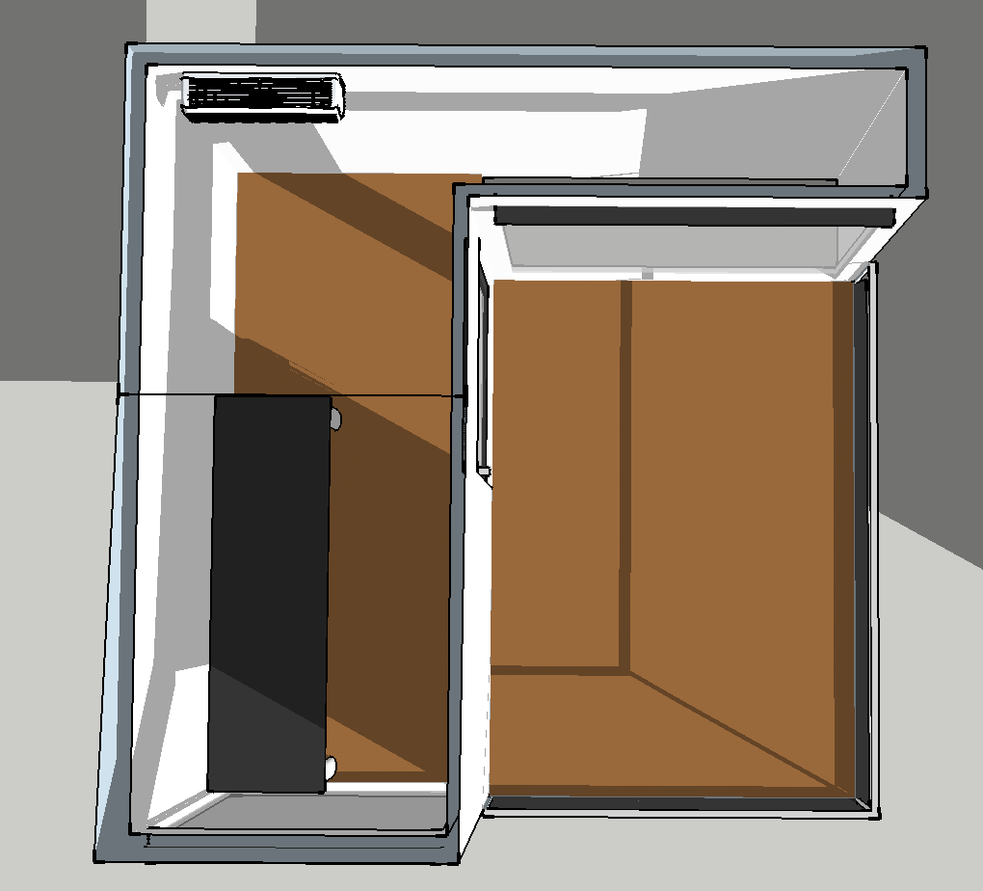

*(Interior of Level 2 Clubhouse)*

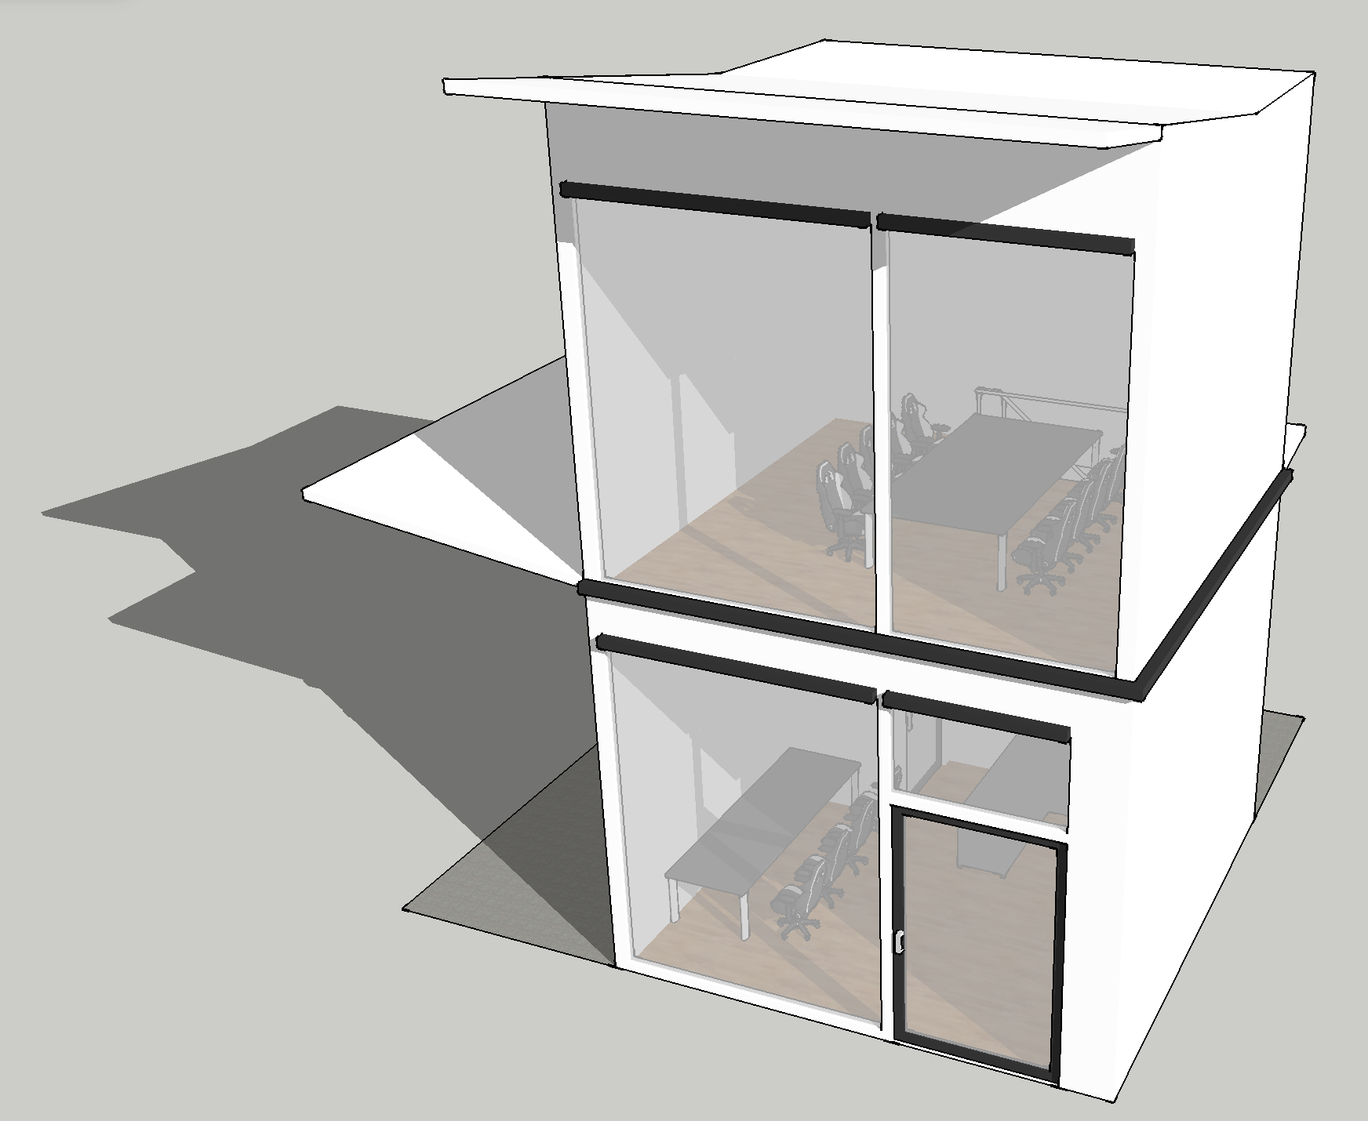

*(A concept of the Gaming Room)*

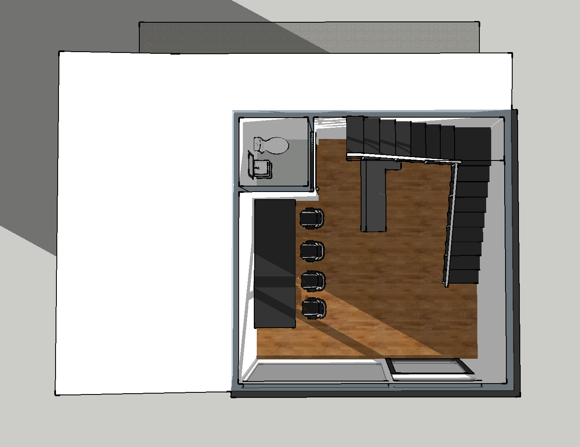

*(An interior view of Level 2 Gaming Room)*

* **Storage Space**

In every InnAcc, a tiny area will be reserved and dedicated for storage purposes. This

serves as an area to store bulky/large items such as bicycles and bags. This gives users

more room to use in InnAcc, utilizing the space to the fullest.

* **InnAcc Rules for Users**

We plan to put in place rules in InnAcc to prevent abuse by users. This is similar to how

Ngee Ann Polytechnic’s school library has a rule board in each room booked by

students. The public is strongly encouraged to follow these rules to create a conducive

environment for everyone to use InnAcc. This also helps maintain InnAcc’s image in the

long run should the public adhere to the rules set in place.

# **Concerns by the Consumers**

According to the responses we have created, we have noticed that the main concern of our product, InnAcc is the limit of the number of people that is able to use InnAcc. As the size of our original concept was fairly small, it might not be able to host a large number of people for larger events like parties. As a result, to address this concern, we have decided to implement a variety of rooms that will cater to the needs of each group of users so that a large number of activities will be able to be carried out/performed in our InnAcc.

# **Conclusion**

At the start of our project “InnAcc”, our main aim was simple - to provide users at East Coast Park a place to conduct their own activities designed and dedicated to their private and personal usage. However, after conducting the “InnAcc survey” and collating all the responses from users of all ages, we found out that we could improve InnAcc much further. Adding features such as “Barbeque Pit”, “Convenient Booking Scheme” and “InnAcc rules”. All these features have helped InnAcc to be much more attractive to the public.

# **Appendix A - Market Research Questionnaire**



 